**Shabbos Stories For**

**Parshas Seitzei 5785**

Volume 16, Issue 49 13 Elul 5785/September 6, 2025

**Printed L’illuy nishmas Nechama bas R’ Noach, a”h**

For a free subscription, please forward your request to ***keren18@juno.com***

***Past emails can be found on the website – ShabbosStories.com***

**Was it a Waste of Time?**

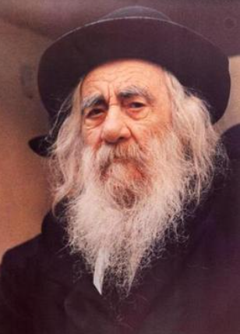 

**The Steipler Gaon**

Rav Gamliel Rabinowitz told a story. There was a Talmid Chacham who lived in Tel Aviv. Every morning, he would get up early and travel to his Kollel in Bnei Brak. He would Daven Shacharis and remain the whole day to learn until evening. One morning he had to take care of something, and he left to Bnei Brak after he had Davened in Tel Aviv.

Because of this, he missed his usual ride, and he was forced, to his dismay, to take the bus filled with young college students travelling from Tel Aviv to Bar Ilan University, which was on the way to Bnei Brak. Those secular boys were noisy and joking around the entire time, but he paid no attention to them. He sat to the side and learned the Sefer Mishnah Brurah, which he always learned when he traveled.

One boy from the group who was sitting near him was taken by how the young man was concentrating on his studies, and how he was not interrupted by the noise and commotion that was going on around him. He wanted to know what this young man was so involved in, to the extent that he was unaware of anything that was going on around him, and he was not at all distracted. He wanted to start a conversation with the young man, so he asked, “Excuse me, please. What is that book you are holding? I see that you are so absorbed in it!”

Since the boy asked his question respectfully, the young man decided to reply and explain about the Sefer he was learning. He described in detail about the amazing Sefer, the Mishnah Brurah, that was known all over the Jewish world, and he explained about the author, the Chofetz Chaim.

But the boy was not satisfied. He became more and more interested, specifically about the text at the top of the page, which is the Shulchan Aruch, and the two sections that are below it, the Be’er Heiteiv and the Sha’arei Teshuvah, and the two sections below that, the Mishnah Brurah and the Biur Halachah, and the section that is below them, the Sha’ar HaTzion, and also about the above side column, the Be’er HaGolah.

The young man patiently explained every detail, the order of the generations of the various commentators, how each section was added one after the other, how every author saw the authors before him and only then added his own commentary to it. He showed him the layout that was set up by the Rama, which was printed using Rashi’s script, on the Shulchan Aruch, which was arranged by the Mechaber. He then explained all the letters added in the Shulchan Aruch to direct the reader to the correct commentary on the bottom, each commentary using a different form of the alphabet. They sat and discussed these things until the bus arrived at the stop before Bnei Brak, where the boy got off the bus together with the rest of his friends going to Bar Ilan.

Afterwards, the young man thought about the conversation he had with this college boy, and his heart filled with regret. He said, “Why did I waste my precious time on this whole long trip? If the conversation was in words of Torah, or at least in words of Chizuk or Mussar, then that would be fine, but all we talked about was history and the layout of the text on the page! It was just a college student who likes to investigate dry topics like the history, the authors, and the different formats on the page of the book, but he had no interest in the Sefer itself. I wasted all my time!”

This young man had a pre-arranged appointment with the Steipler Gaon, zt”l. Since he was still disturbed by his conversation with the college student, he decided to ask the Rav about it to settle his mind. The Steipler told him that in his opinion, he did the right thing and the time was well spent, as it is not possible to know what effect his words would have, or when they might affect the boy. Who knows what was implanted in the heart of this college boy.

As it says about the great Tanna Rebbe Akiva in Avos D’Rebbe Nassan (6), about the origin of Rebbe Akiva. He was forty years old, and he had not yet learned anything. Once, he was walking by a rock and he saw that over time, dripping water had made an indentation in the rock. He said to himself that if something soft like water can damage something hard like a rock, then words of Torah can penetrate even into his own heart! He immediately went to learn Torah.

The Steipler explained that even a small conversation like this one, about the author and his book, can make an impression, and it is not possible to know what the results will be in the future. He said, “Perhaps in a few years this boy will come upon a Mishnah Brurah, and then since the Sefer is already close to his heart because there is some familiarity already due to the conversation that you had with him, he will be interested to look into it. Perhaps this conversation was only the first drop of many that the Hashem wanted to come about, in order to save a Jewish Neshamah and bring it closer to the truth, and return it to its rightful place.”

The young man was indeed calmed from the insightful words of the Steipler Gaon!

*Reprinted from the Parshas Va’eschanan 5785 email of Rabbi Yehuda Winzelberg’s Torah U’Tefillah.*

**The Praiseworthy Tzedaka**

**of the Rebbe of Viznitz**

**By Yehuda Z Klitnick**

Rav Baruch Sternschuss was among the prominent Chassidim of Harav Menachem Mendel Hager, known as the Tzemach Tzaddik of Viznitz (1830 - 1884). He related this story that happened to his uncle, Rav Chaim Sternschuss. Rav Chaim was a merchant and had business ties in many countries, and therefore traveled a lot. He was blessed with wealth, and also didn’t waste his time. He made sure to toil in learning, and was a Talmid Chacham. This contributed to his success, as he was well respected by the merchants, and he frequently told over “a nice Dvar Torah.”

Lemberg, a major city, was always thriving with fairs and markets, and as such, Rav Chaim frequently traveled there. The Rav of Lemberg at the time was the great Rav Yosef Shaul Natanson, author of Responsa Shoel Umeishiv, as well as of Divrei Shaul and other seforim (1800- 1875). Rav Chaim went to the shul where Rav Yosef Shaul davened, and it came about that they immersed themselves in a discussion in learning.

Being Talmidei Chachamim, they spoke for a few hours in heated debate. Rav Yosef Shaul asked a question, Rav Chaim answered, and so forth. After a few hours had gone by, without realizing the time frame, Rav Yosef Shaul the merchant and asked Rav Chaim: who was his Rebbe? He answered that he was a Chosid of the Viznitzer Rebbe.

Rav Yosef Shaul smiled and said: “I will tell you a beautiful story showing the greatness of your Rebbe.”

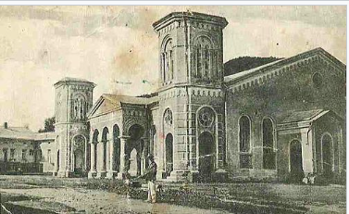

The Chassidic synagogue in Viznitz

Rav Yosef Shaul continued: “In Lemberg there is a resort area where many Rabbonim and Rebbes come to rest and use the warm spas. I have noticed that some Rabbonim don’t necessarily go just for pleasure. Many Yidden who come there are relaxed and ready to discuss anything. This is the perfect time for bringing them closer to Hashem with Divrei Chizuk and Mussar, which really works wonders!

“A wealthy Yid from Russia, a Talmid Chacham, was at the resort at the same time as the Viznitzer Rebbe, and they really connected to each other in learning. The Yid was so excited with the time spent with the Rebbe, that he made sure to come every year to the resort at the same time that the Viznitzer Rebbe came. One year, someone proposed a shidduch for the daughter of the Russian Yid.

Since he was wealthy, a very good boy from Lemberg was offered to his daughter, and a large dowry was set. Being wealthy, he had no problem in promising such a dowry. The Yid met the boy and saw that he was a good learner and the shidduch was made. The contract was written up, and the dowry and presents were to follow in due time.

The Yid came home with the good news that his daughter was engaged to a special boy from Lemberg. He told his wife that the dowry and presents would be forthcoming soon. Hashem had other plans however, and slowly he began to lose money in his dealings, until he lost all his money!

Meanwhile, the boy’s father began to inquire when the presents and dowry would to be delivered to them in Lemberg. However, the letters were not answered, and therefore a warning letter was sent, stating that they would cancel the shidduch if there was no response! The Yid from Russia had no choice, and answered that he would be’ezer Hashem, bring the dowry and presents to the wedding, and the plans for the wedding should proceed.

The boy’s father was satisfied, as he knew the Yid was a wealthy and prominent Talmid Chacham, and he answered that he would be setting a day for the wedding. The date of the wedding was approaching. The Yid felt that since he was very close to the Viznitzer Rebbe, and the Rebbe was known to be a big Baal Tzedaka, he would make a stop in Viznitz on the way to Lemberg, and the Rebbe would help him out with the expenses of the wedding.

The family came along, and while in Viznitz they went to a hotel to rest, and the Yid went to visit the Rebbe, who was excited and glad to see him and immediately they began a discussion in learning. After a while, the Yid told the Rebbe that he was on the way to Lemberg for the wedding of his daughter and that he must come up with the dowry and presents; however, he is now a poor man and has no money to give for the wedding!

The Rebbe asked how much he needed, and he answered. The Rebbe gave him a warm bracha and told him to go "l'chaim ul’eshalom! The Yid was led out of the room, totally in shambles. How could the Rebbe do this to him? But then, something told him that the Rebbe would definitely be of help, and he calmed down. He now decided to make the trip to the wedding, and Hashem would help him.

The Yid picked up his family from the hotel and went to get the train to Lemberg. It was a long trip. When the family embarked from the train, the Yid heard that someone was looking for him. He inquired who it was, and he noticed two young Chassidim waiting for him.

He introduced himself to the Chassidim, and they told him to meet them at the Shul in Lemberg. The Yid had no idea what they had in mind; however, he went to the Shul. They told him, that they were Viznitzer Chassidim and the Rebbe sent them a message to deliver a package! When he opened it, he noticed that there was a large sum of money inside, and he thanked the Chassidim for the money.

At the hotel in which he stayed, he counted the money, and to his astonishment, the money was enough for the dowry and presents, as well as some extra! The Yid went straight to the Mechuten and paid the dowry and gave others the presents. The wedding was performed with Mazel. On his way back, he went to thank the Rebbe for his kindness. The Lemberger Rav concluded: To such a Rebbe, who knows how to give Tzedaka in a discreet manner, I would travel to him too!

*Reprinted from the Parshas Devorim 5785 email of Pardes Yehuda.*

**Why Didn’t You Slap that Student Who Insulted You?**

Horav Yechiel Michel Stern, Shlita (Rav of Ezras Torah), related the following story, which demonstrates how a seasoned mechanech, educator, a Rosh Yeshivah known for the love he showed his talmidim, rendered rebuke. Horav Yaakov Neiman, zl, stood at the helm of Yeshivas Ohr Yisrael in Petach Tikva – a yeshivah that produced many dynamic Torah leaders, as well as laymen for whom Torah study was their primary vocation.

Rav Stern had a roommate who was also his chavrusa, study partner. He was a frum, observant, boy who liked to have a good time. Suffice it to say that he danced to his own beat, which often did not align with the yeshivah’s rules. The Rosh Yeshivah would take a daily walk, accompanied by one of his students. It was a time for learning and an opportunity to point out areas in which the student could grow spiritually. In short, it was an unprecedented opportunity for a ben Torah to receive guidance and chizuk from a premier Rosh Yeshivah and mechanech.

That day, Rav Yechiel Michel was selected to walk with Rav Neiman. Everything was going smoothly until Rav Yechiel Michel saw his friend walking toward them.

“This cannot be good,” he thought to himself. His friend met them. The Rosh Yeshivah asked him, “Where are you going?”

With a defiance born of pure chutzpah, the bochur replied, “To see a film at the theater.”

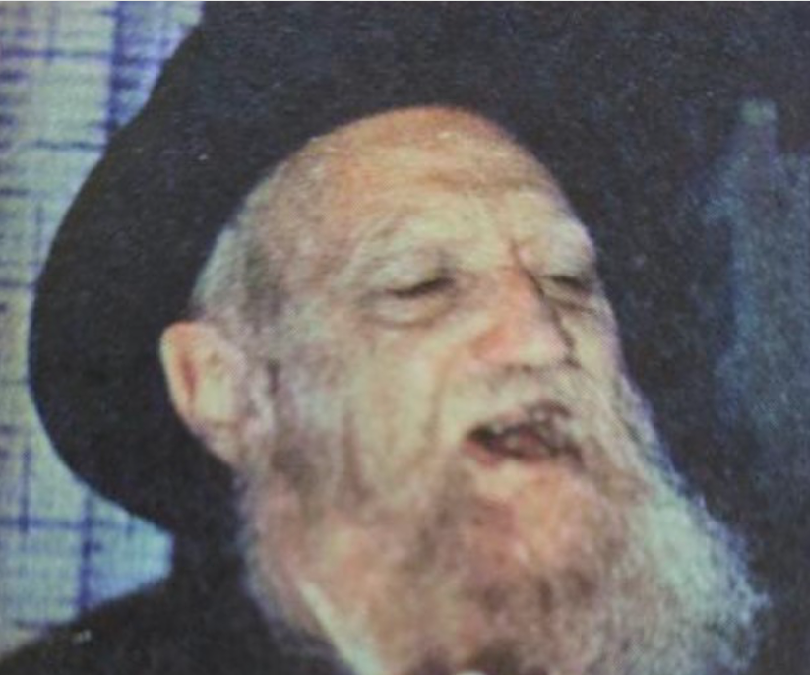

**Rav Yaakov Neiman**

When Rav Yechiel Michel heard this, he was certain the Rosh Yeshivah would administer a resounding slap to the face of his friend. He did not; rather, he said, “It is cool outside, and it is a bit of a distance to the theater. I suggest that you return to the dorm and put on a sweater.”

This was too much for the young future Rav of Ezras Torah to contain. When he returned to the yeshivah, he went up to the Rosh Yeshivah and asked for an explanation. A student had openly flaunted a behavior unacceptable in a yeshivah milieu. Furthermore, he had spoken to the Rosh Yeshivah with a smug attitude that bordered on chutzpah.

The Rosh Yeshivah countered, “How many years have you been a Torah mechanech that you feel secure in making such a judgment call? I have been a Rosh Yeshivah for over half-a-century. Leave the decisions to me.”

That night, the bochur was very agitated. He could not understand why the Rosh Yeshivah had not excoriated him for his behavior. He was certain that the next morning he would be sent home. The following morning, the Rosh Yeshivah was deep in conversation with the Mashgiach, under whose purview daily discipline of the talmidim fell.

The bochur was certain he would be called over by the Mashgiach and asked to leave. He knew that he had acted inappropriately and was prepared to face the music. Nothing happened. Another day passed, and he could no longer tolerate the anxiety. He had done wrong, and he expected to be punished. What was taking so long? That night, he was climbing out of his skin.

He asked to see the Rosh Yeshivah. He walked into his office and broke down in copious weeping. “I acted inappropriately. I went where I was not supposed to go, and I spoke to the Rosh Yeshivah with chutzpah. I beg forgiveness, and I am ready to accept whatever punishment the Rosh Yeshivah decides is best for me.”

Rav Neiman took the bochur’s hand in his and soothed it, “Your father works for the city – does he not? He probably just barely ekes out a living to support his family. Yet, he values a Torah education so much that he is prepared to deprive himself in order that his children should study Torah. You are the oldest of your siblings. They all look up to you, to the point that the decisions you make concerning your future will greatly impact the path they, too, will choose. Why would you act in an unbecoming manner for a ben yeshivah? Does your father not deserve a ‘return’ on his investment? Do you want to be the catalyst for your brother’s leaving yeshivah and following a way of life not aligned with your Torah potential?”

The bochur heard the message clearly. Rav Neiman’s patience in addressing his innocent behavior saved, not only him, but his entire family. The bochur returned to the gemorah and became an outstanding masmid, diligent student of Torah. Years passed; he sought no position, just learning. When he was ready to get married, he was accepted into one of the most illustrious Torah families.

It was at the chupah that Rav Neiman called over to Rav Yechiel Michel and said, “Nu! What do you think: Should I have slapped him or pinched his cheek?” Perfect students are rare, but so are perfect mentors. When addressing a student’s misbehavior, restraint is not only advantageous, it is essential. While a harsh punishment may correct an action, it can leave a lasting damage on the heart. [I may add that the mentor should first introspect to make sure that he is not acting to assuage his own bruised ego.] A small affectionate gesture, such as a pinch on the cheek, conveys disappointment, while affirming unconditional love and support. It teaches the student that growth is expected, but never at the expense of respect and connection.

*Reprinted from the Parshas Devorim 5785 email of Peninim on the Torah compiled by Rabbi L Scheinbaum of the Hebrew Academy of Cleveland.*

**The Priest Who**

**Taught Torah**

**By Yoni Schwartz**

A non-religious Jewish father was pushed into a corner: in his small town, the high school with the best education was a Catholic private school. Nevertheless, he approached the priest-dean asking if his son, Sam (not real name), could learn there for just secular studies.

The priest, with a twinkle in his eyes, refused: “I’m sorry, if you want him in our school, he must also take religious courses.”

“However,” continued the priest, “since he is Jewish, he must take Jewish courses.”

Confused, the father asked, “But… who will teach him? Nobody in this school is Jewish?!”

The priest, with a smile, responded, “Not to worry. I will teach him!”

He began teaching Sam how to read and write in Hebrew, then taught him Chumash, Nevi’im, and Kesuvim. Soon after, they moved on to *mishanyos* and halacha. After nine months, he told Sam, “I’ve taught you everything I know. Now, you must go to a yeshiva in Israel to continue your education.”

The father, with amazement, looked at the priest and asked, “How do you know all of this, and why did you dedicate countless hours to personally tutor my son?”

The priest responded with the following story:

“As a young man exploring Israel, I visited a place named near the Western Wall, a yeshivah for young men from non-religious homes called Aish HaTorah in Jerusalem. I received a tap on my shoulder, turned around, and saw a saintly-looking individual with a long white beard named Rav Noach Weinberg. I’m assuming he thought I was a non-religious Jew because he immediately struck up a very friendly and entertaining conversation with me, after which he invited me to learn in Aish for a couple of days.

“Those couple of days kept getting extended with his constant encouragement, until I found myself there nine months later. As I was preparing to leave, Rabbi Weinberg asked why I was leaving so soon. I then decided to tell him the truth: that I wasn’t Jewish.

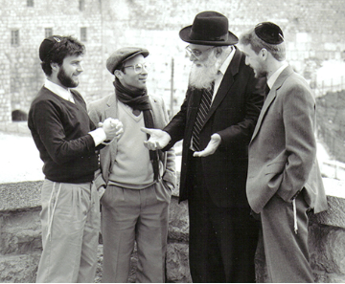

**Rav Noach Weinberg of blessed memory with students at the Aish HaTorah campus in Jerusalem**

He was furious. ‘What! Why didn’t you tell us this earlier? Do you know how much time, money, and effort we invested in you?!’

I begged for his apology, but my pleas fell on deaf ears. After a while, he said, ‘I’ll only forgive you if, one day, you come across a non-religious Jew, teach him everything you learned here and set him on the right path.”

The priest continued, “For years, I have regretted what I did to that sweet Rabbi. I hope he can forgive me.”

[Compiler’s note: According to other versions of this story, the boy did go to Yerushalayim and learned in Aish Hatorah and went on to become religious and start a bayis Yisroel, a Jewish family. I guess Rabbi Weinberg retroactively cheerfully forgave the priest.]

*Reprinted from the Parshas Ve’eschanan 5785 email of Torah Sweets.*

**Let’s Do it Again!**

**By Aharon Spetner**

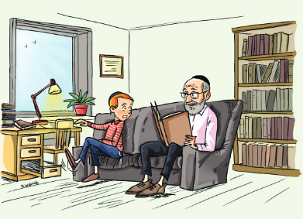

**Illustrated by Miri Weinreb**

Zaidy Holtzbacher opened the front door. “Welcome, Ari,” he said with a large smile. “Come on in. Bubby is making a batch of cookies - they’ll be ready in a minute. In the meantime, why don’t you sit with me in my study? I really want to hear about your family trip.”

Ari sat down on the couch in Zaidy’s study and told him all about the family trip to Fort Knox. “There was so much gold there,” he said.

“I could imagine,” said Zaidy. “Did they let you take any home as a souvenir?" Zaidy winked.

Ari laughed. “No, Zaidy, of course not. But they told us that just one pound of gold costs $50,000 - and a pound of gold is so small it can fit in your hand! And Totty did the cheshbon of the size of the kapores on the aron in the Beis Hamikdash - it would take 150 million dollars worth of gold to make the kapores! That means the aron weighed more than a car! Can you imagine how strong the Leviim who carried it had to be?”

“Well Ari,” said Zaidy. “Chazal tell us that the aron carried those who carried it. So they didn’t have to worry about how heavy it was.”

“Zaidy,” said Ari suddenly, noticing an open drawer in the desk. “What are those big scary knives?”

“Oh, those are my shechitah knives,” said Zaidy.

“Wait, you’re a shoichet?” Ari asked.

“Well, I was. Many years ago, before the fall of the Soviet Union, there were still a few Yidden living in the shtetl of Horki. I was still in kollel, and the Horki Rebbe asked me to learn to be a shoichet for the Yidden living there so they could have kosher meat. I spent years learning hilchos shechita - it’s a big responsibility being a shoichet. The smallest mistake can chas veshalom cause a Yid to eat meat that isn’t kosher.”

“That’s incredible,” said Ari. “So how long were you a shoichet for?”

“Not long at all,” laughed Zaidy. “Three weeks after I arrived, the Soviet Union fell and the Yidden of Horki moved to Boro Park to live close to the Rebbe. I had only shechted one cow, but I wasn’t needed as a shoichet anymore so I came back and when your father opened his business I started working for him, since there weren’t many openings for shechitah jobs here in Boro Park.”

“Oy, that’s terrible,” lamented Ari

“Why would it be terrible that Yidden got to escape the Soviet Union?” asked Zaidy.

“No, I mean the fact that you spent all those years learning to be a shoichet and it was all for nothing.”

“For nothing?” asked Zaidy, shocked, as Bubby came into the room with a plate of hot steaming chocolate chip caramel fudge cookies with sprinkles and marshmallow bits. “Learning Torah is never for nothing.”

“Yeah but the reason you learned those halachos so many times was so you could become a shoichet. You could have been learning other things instead of just focusing on that.”

“Ari,” said Zaidy. “In this week's Parsha it says “ViShinantam.” Do you know what that means? It means it’s not enough just to learn Torah. We need to repeat everything that we learn over and over and over again. No matter how many times we learn something, each time we learn something new and the Torah becomes more and more a part of us. Imagine spending time planting a field of wheat and never harvesting that wheat.”

“That would be silly,” said Ari.

“Exactly. And learning without chazering it is just as silly. Each time we learn Torah we must remember to go back and learn it over and over again many, many times. So, I was zoche to learn hilchos shechitah for years and for those heiligge halachos to become a part of who I am.”

“Oh,” said Ari, realizing something. “When we make a siyum we say ‘hadran alach’. ‘Hadar’ in Aramaic means to return. So, we’re saying now that we finished learning something, we are going to return to it, to go back and learn it again?”

“Correct!” Zaidy said, with a big smile. “That’s why if someone wants to tell you a dvar Torah which you heard before, never say ‘oh I heard it already’. Listen to him tell it to you again. Each time you hear it, you are making the divrei Torah part of who you are as a Yid.”

*Reprinted from the Parshas Va’eschanan 5785 email of Toras Avigdor Junior based on the Torah teachings of Rav Avigdor Miller, zt”l.*

**Cementing One’s Love for**

**the Mitzvah of Shabbos**

There was once a talmid chacham who recounted a personal story that proves a point. When he was young, his father was a contractor who was charged with building the first twenty houses in a new settlement in Eretz Yisroel. This was a huge opportunity but it involved great expense for his father. The biggest expense he had with the construction of the buildings was the cement, for he had to import it at great cost from outside the land.

On one occasion, the cement delivery arrived one Friday afternoon in the summer, hundreds of open barrels of cement. After they had taken the delivery it was already late in the afternoon so all the Jewish workers went home to their town of Yaffo. Suddenly, the sky went dark and it looked like the heavens would open up at any moment and there would be a massive storm.

The workers came running over to the boss and told him they must go back since all the barrels are open and if it rains, the cement will get wet, harden and be ruined, a tremendous loss. “We have to go back and cover the barrels.”

However, with little time left until Shabbos it would be impossible to do the job without desecrating the Shabbos. The righteous builder did not even hesitate for a second. “No!” he said defiantly, “I will not sell Shabbos for all the money in the world. No one should go back and desecrate the Shabbos for me.”

As expected, that Friday night it poured and poured. It was obvious that this man had lost a fortune, however, he acted as if nothing had happened. He maintained a smile on his face, sang zemiros and talked divrei Torah at the meals acting as he would on any other Shabbos, truly personifying that on Shabbos one must feel as though all his work is done.

Soon after Shabbos concluded, he began to think about his great loss and how all the cement that he paid so much for all went to waste. He took his wagon and went to see the damage for himself. As he got closer to his building site, he couldn’t believe his eyes. All his barrels of cement were totally covered-and-sealed, nothing was lost. He couldn’t believe it and wanted to touch the miracle with his own hands. He went over to one of the barrels, took off the cover, ran his fingers through the cement and, yes, it was still dry and good for use, clearly a miracle.

Later he found out that the local street pavers had sent people to go cover their barrels of cement. In the confusion of the darkness and the impending storm, they went and covered the wrong barrels of cement. The barrels belonging to the town were ruined, while the builder’s barrels were all dry and protected, saving him a fortune.

This man, whose dedication to Shabbos was unwavering, who acted like he didn’t have a care in the world on Shabbos, was blessed with Hashem’s protection and as a result Hashem made sure he was taken care of. So, too, if we would recognize that success happens through the hand of Hashem, we too, will be able to really make the Shabbos holy! (Bait Aaron Torah Center)

*Reprinted from the Parshas Vaeschanan 5785 email of Torah Tavlin*

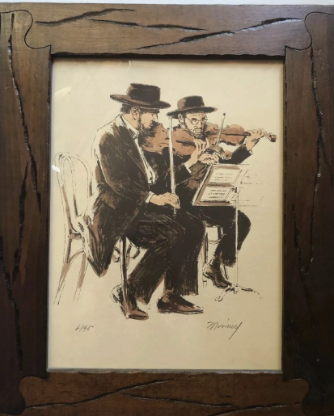

**Antique Vintage Judaica Jewish Lithography – Pencil being offered on eBay.**